**Virtualization:**

Virtualization creates a virtual version of underlying services, enabling multiple operating systems and applications to run simultaneously on the same hardware, improving utilization and flexibility.

Application virtualization:

* **Application virtualization in cloud computing** refers to the technology that enables applications to be run in an isolated and virtualized environment, separate from the underlying operating system or hardware
* This abstraction allows applications to operate consistently across different devices and platforms, simplifying deployment, management, and scalability.

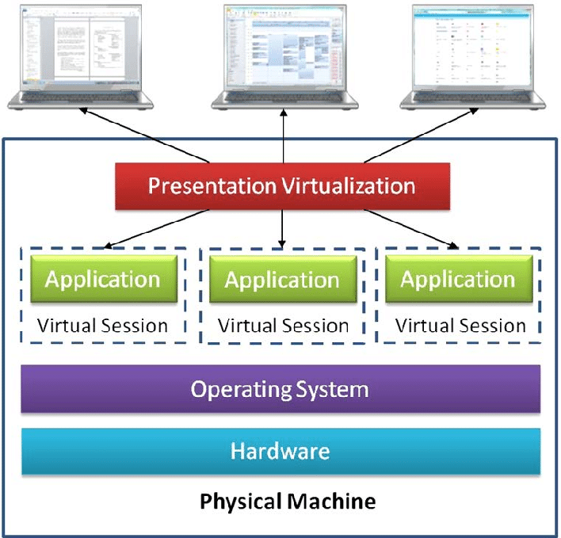

Key Aspects of Application Virtualization:

* **Isolation**:
  + Each application operates in its own virtualized environment, which isolates it from other applications and the host OS. This improves security and reduces conflicts.
* **Portability**:
  + Applications can run on various platforms without needing modifications, as the virtualization layer handles compatibility.
* **Centralized Management**:
  + Applications are stored and managed on central servers and streamed to user devices, ensuring consistency and ease of updates.
* **Scalability**:
  + In cloud environments, virtualized applications can scale dynamically to meet demand, leveraging the underlying infrastructure.

Benefits of Application Virtualization in Cloud Computing:

* **Platform Independence**:

Applications can run on any device, irrespective of the underlying OS or hardware.

* **Enhanced Security**:

Isolating applications prevents one compromised application from affecting others or the system.

* **Simplified Maintenance**:

Updates and patches can be applied centrally, reducing management overhead.

* **Optimized Resource Usage**:

Virtualization ensures efficient use of resources by allocating just enough for each application.

Examples of Application Virtualization Tools:

* **VMware ThinApp**:
  + Packages applications into a single executable, eliminating installation needs.
* **Microsoft App-V (Application Virtualization)**:
  + Provides real-time streaming and centralized management of applications.
* **Citrix Virtual Apps**:
  + Delivers applications securely on any device, simplifying remote work setups.